EXP NO 3:

Create a simple cloud web application for student counselling system using any Cloud Service Provider to demonstrate SaaS with the fields of student name, age, address, phone, subjects studied, Year of passing, percentage of marks, domain interest, etc.

DATE:

AIM:

To Create a simple cloud software application for Student Counselling System using any Cloud Service Provider to demonstrate SaaS.

PROCEDURE:

Step1: Go to zoho.com.

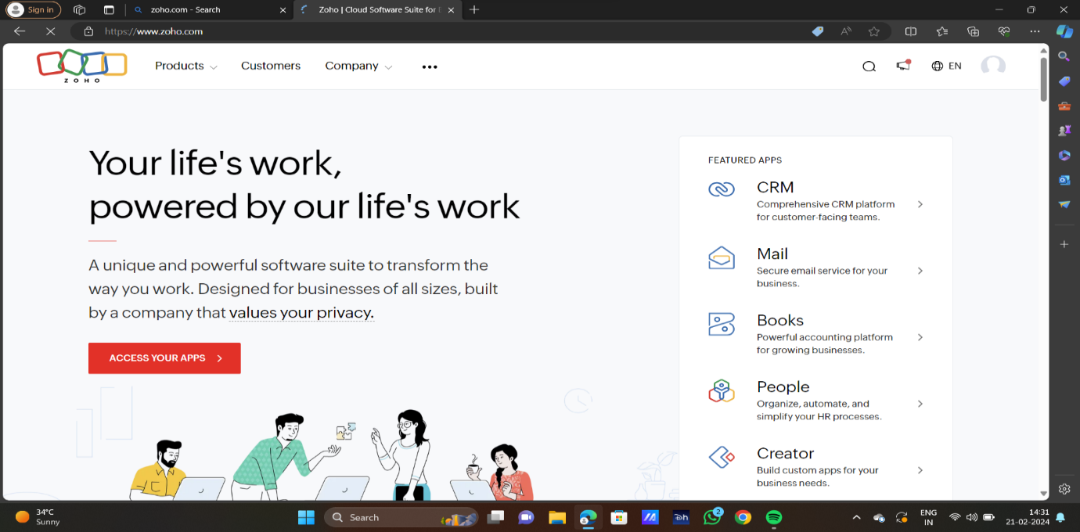

STEP2:LOG INTO THE ZOHO.COM

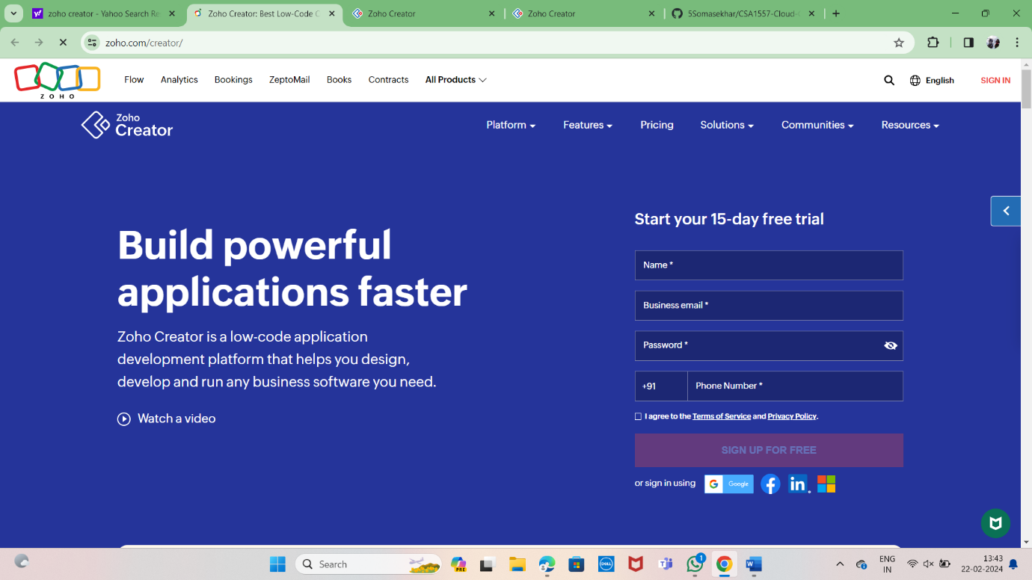

STEP3: SELECT ONE APPLICATION

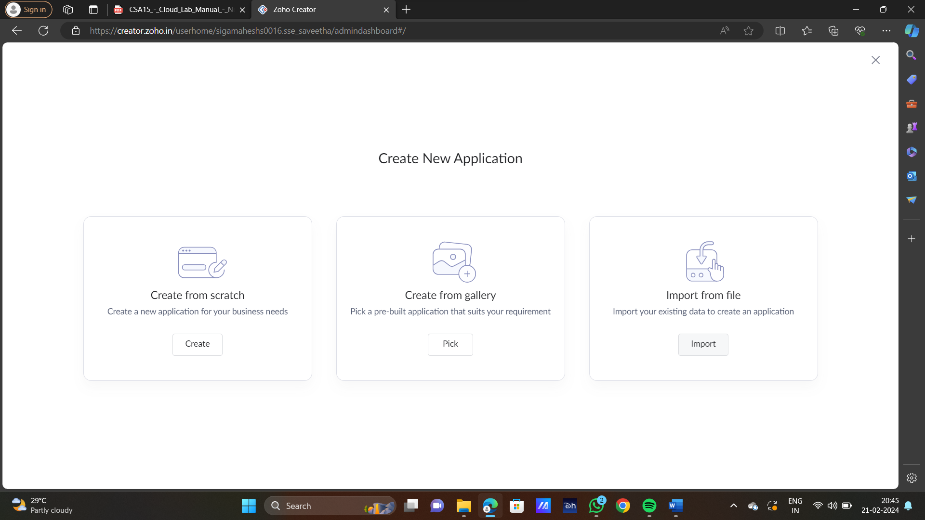

STEP4: ENTER APPLICATION NAME

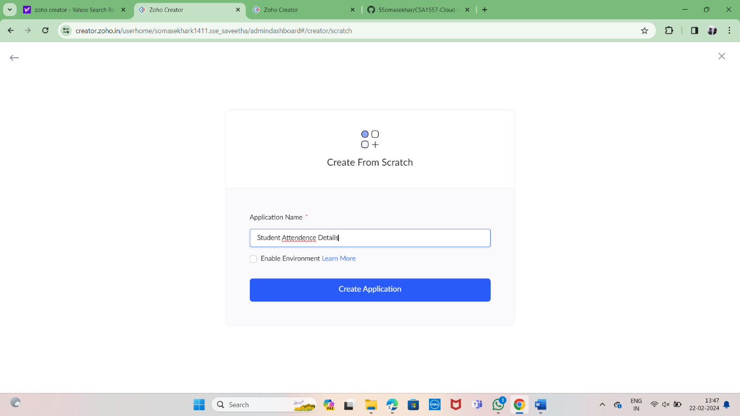

STEP5: CREATED NEW APPLICATION

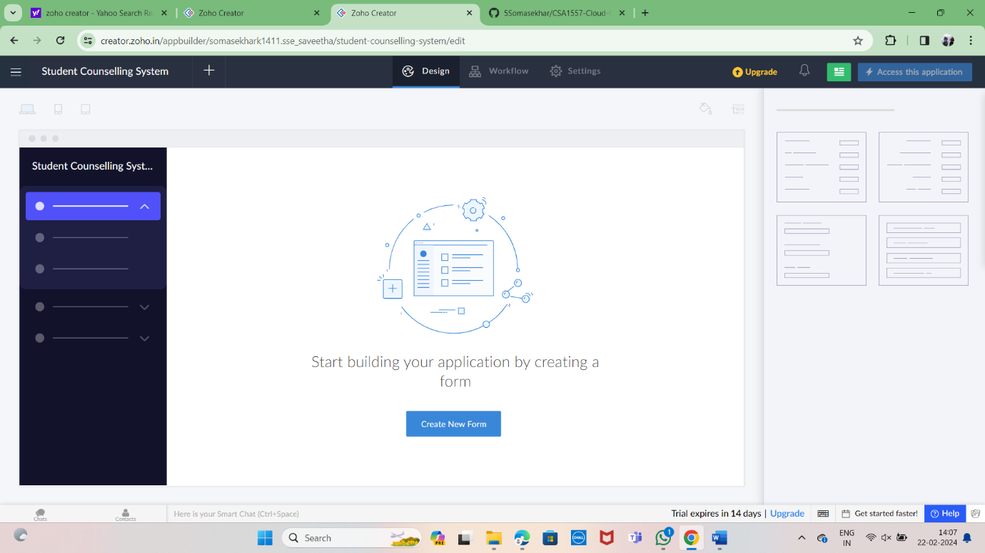

STEP 6: SELECT ONE FORM

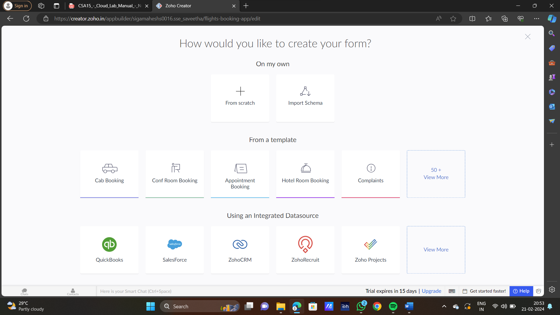

STEP 7: THE SOFTWARE HASE BEEN CREATED.

